Python- notes/key concepts

Variables and functions

* Variables assigned by =, must have ‘ ‘ or “ “ around what they are assigned to
* A function is a set of code that runs when called, must be within the same indentations
* Functions are defined by def
* Call the function by its name then ()
* 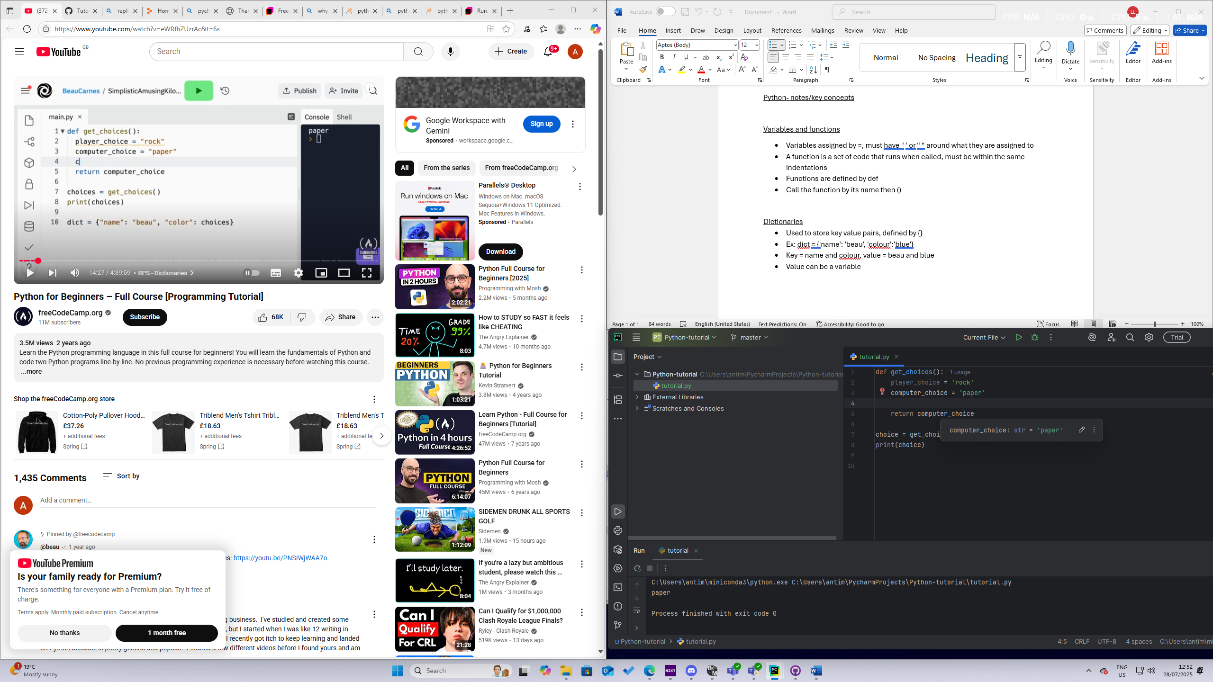

Dictionaries

* Used to store key value pairs, defined by {}
* Ex: dict = {'name': 'beau', 'colour':'blue'}
* Key = name and colour, value = beau and blue
* Value can be a variable
* 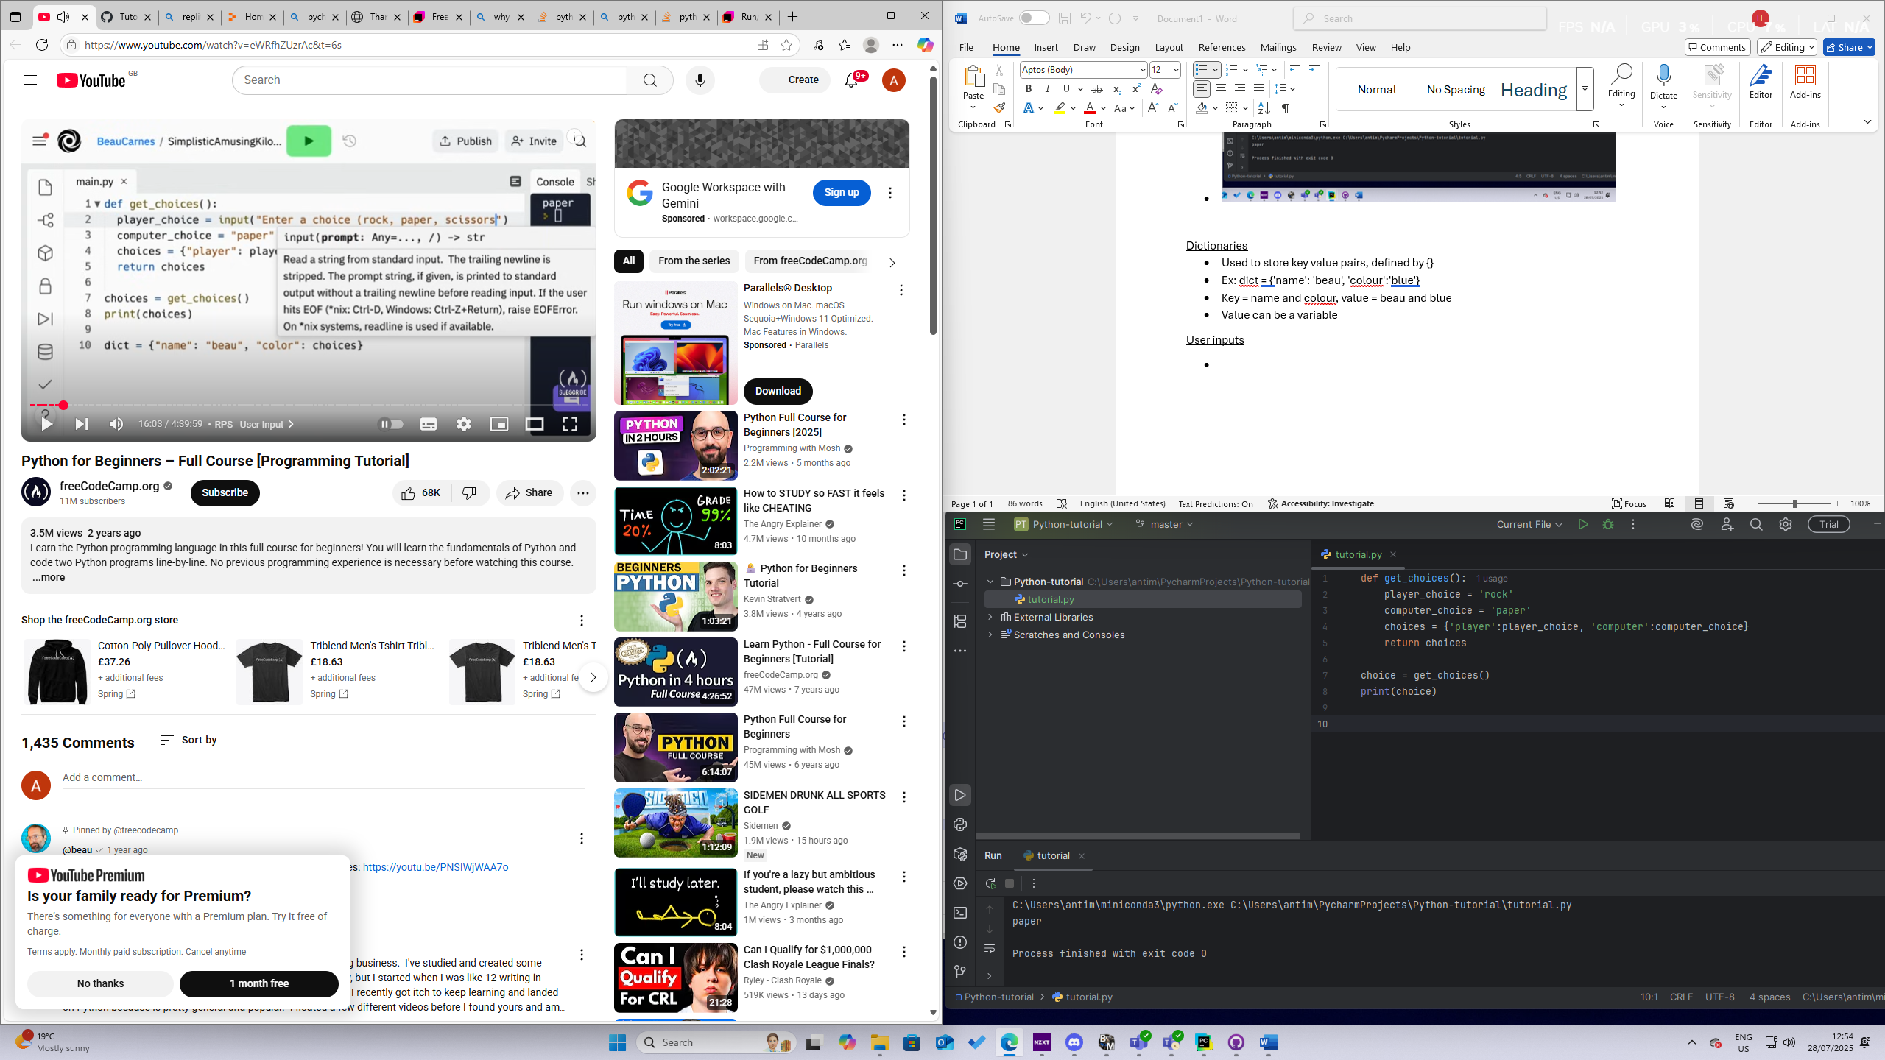

User inputs

* Variable name = input(‘……’)
* 

Libraries,lists,methods

* Import random adds the random function
* Lists store items and each item is separated by a comma
* Example: food = [‘pizza’, ‘carrots’, ‘eggs’]
* 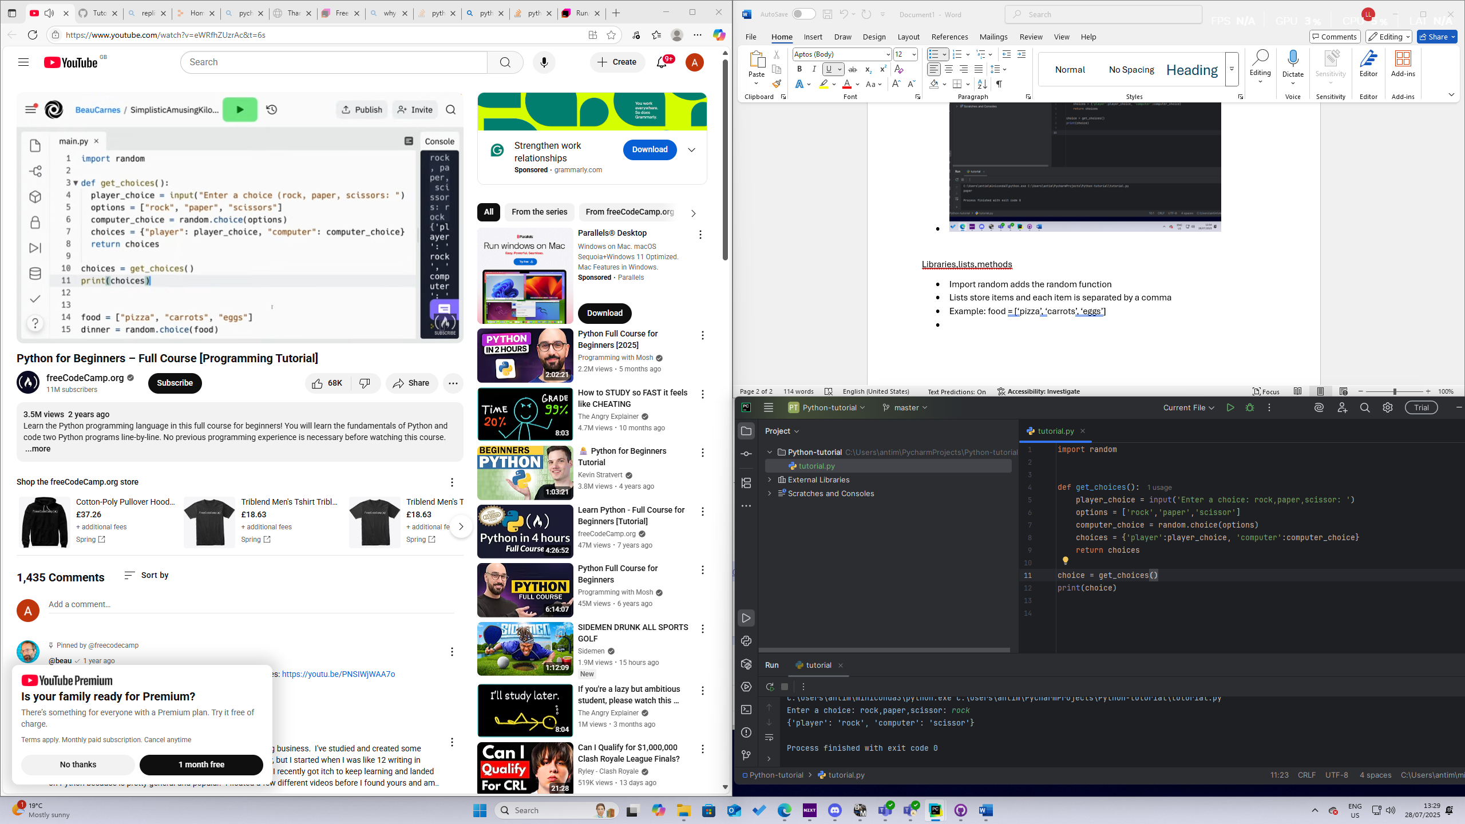

Function arguments

* Arguments are specified in the parenthesis of the function
* Can be called whatever you want

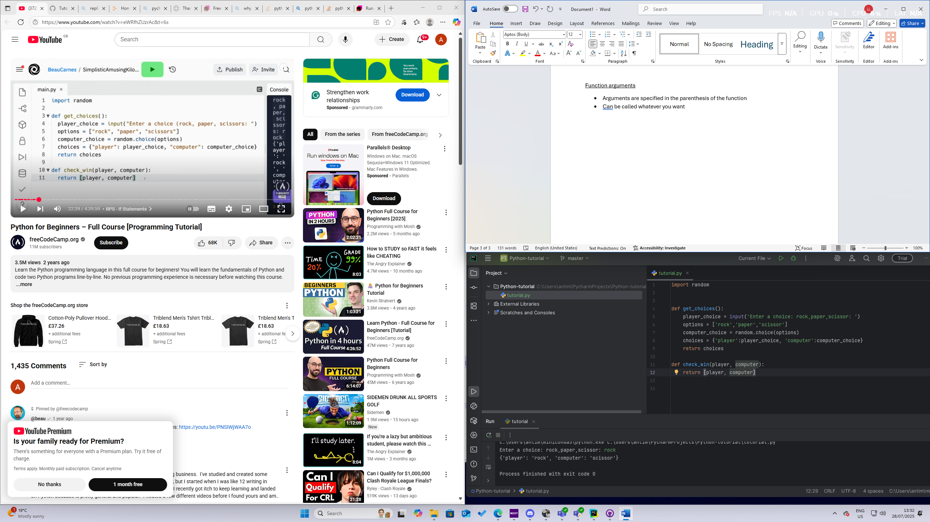

If statements

* Checks conditions, == to check if 2 variables are equal to eachother
* 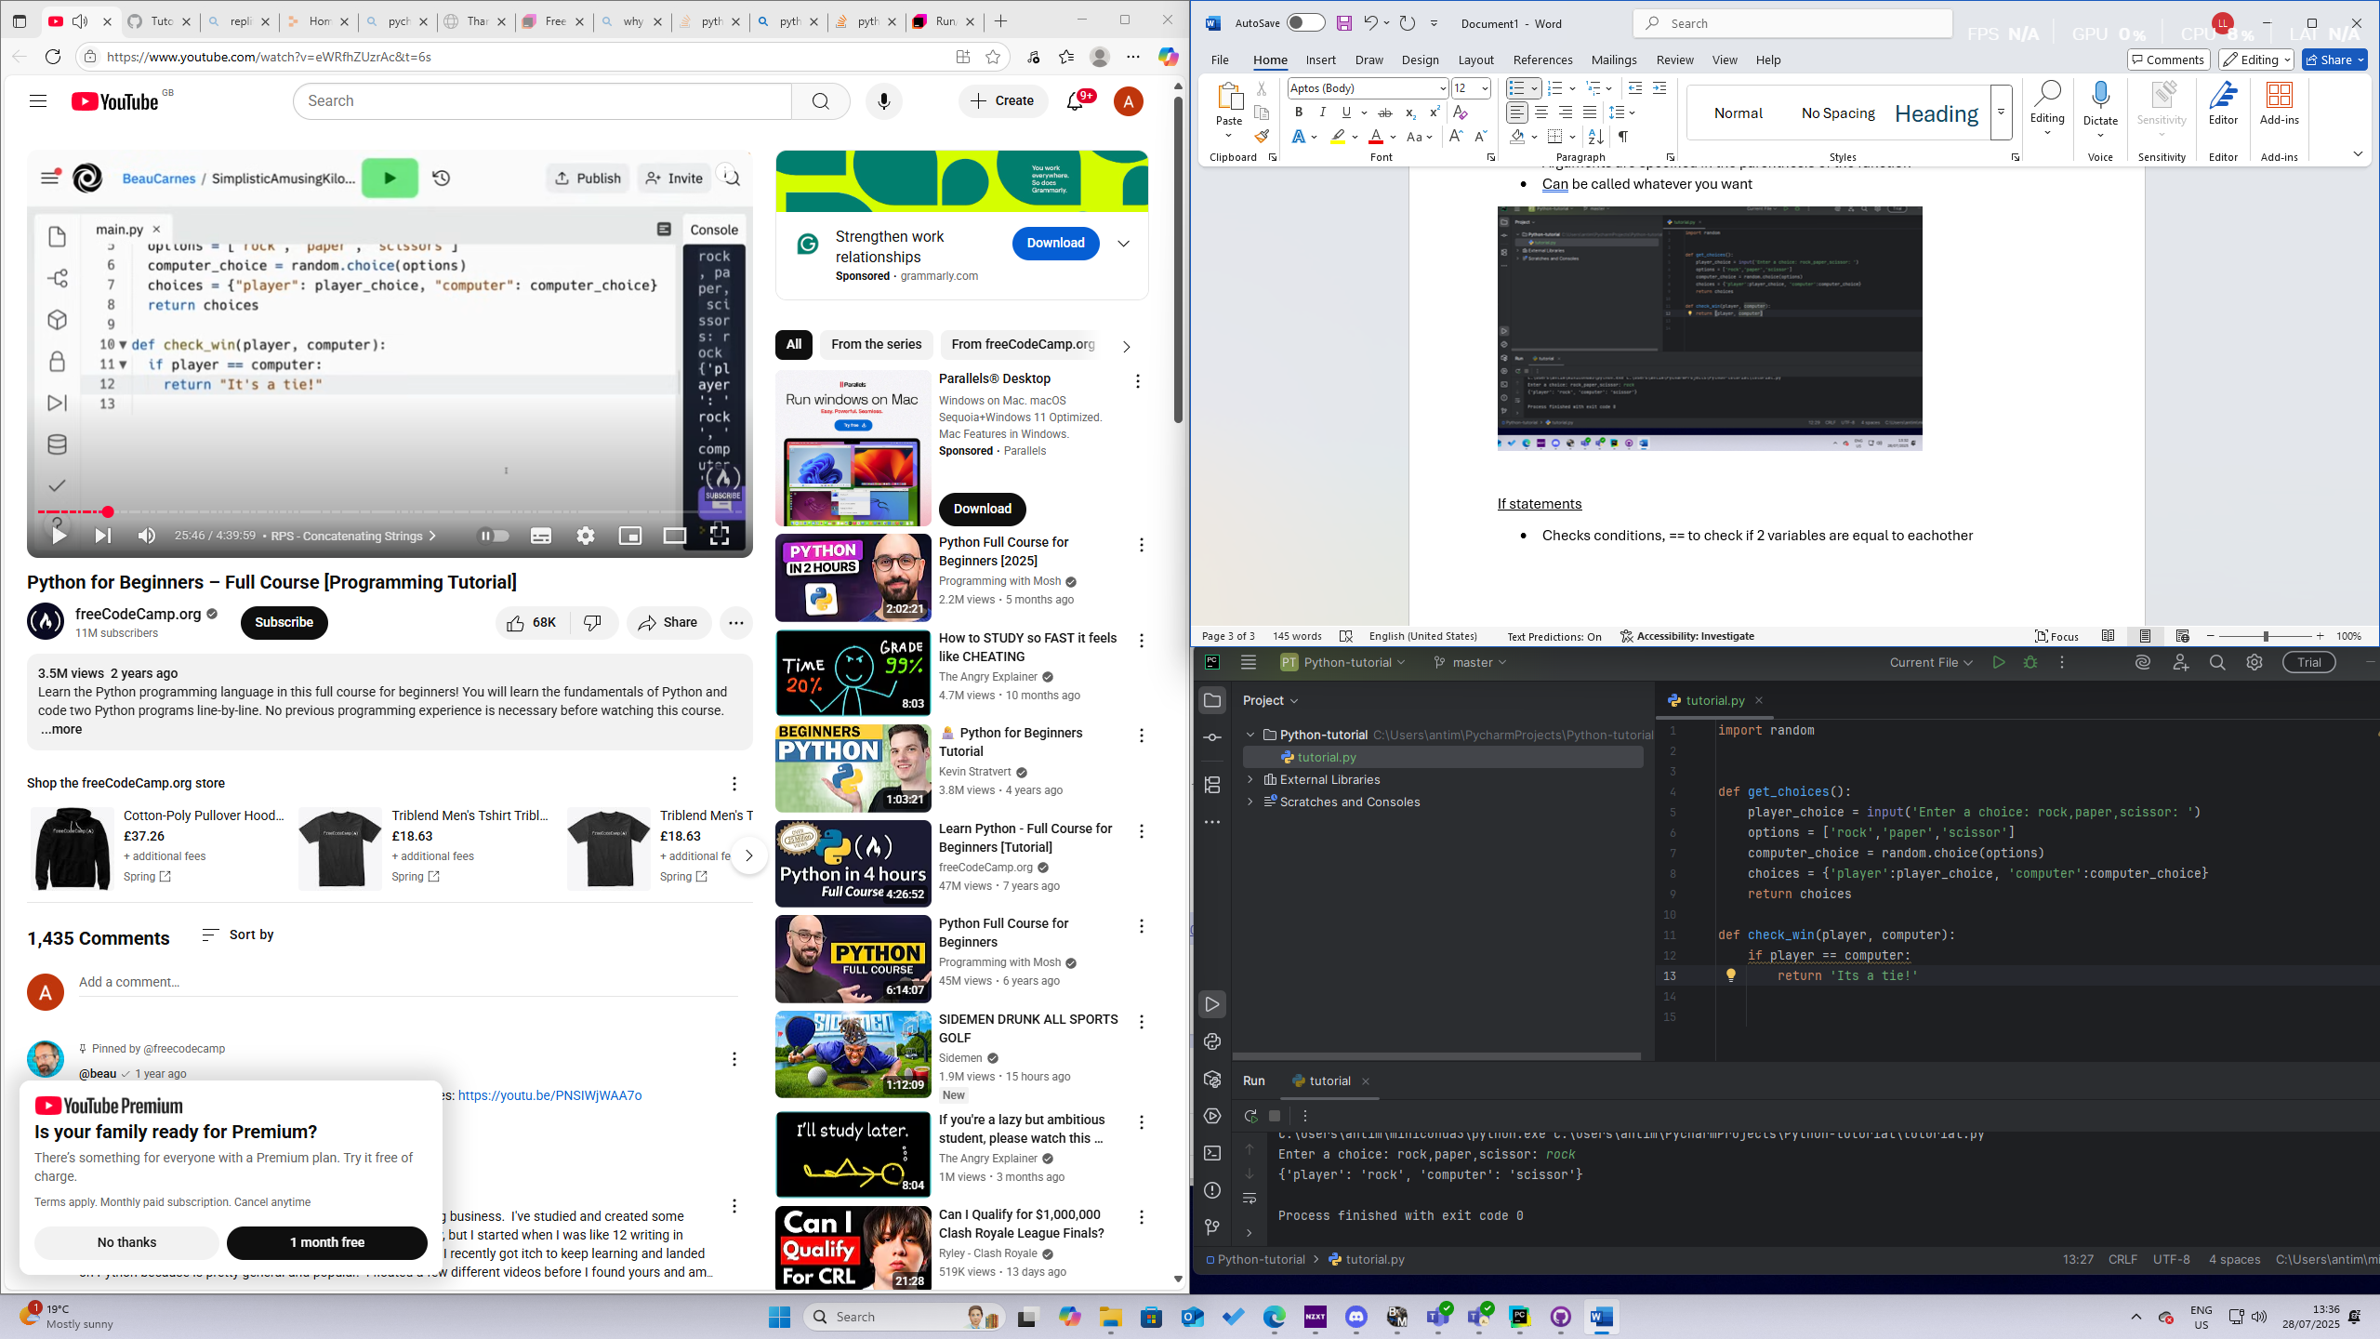

Concatenating strings:

* 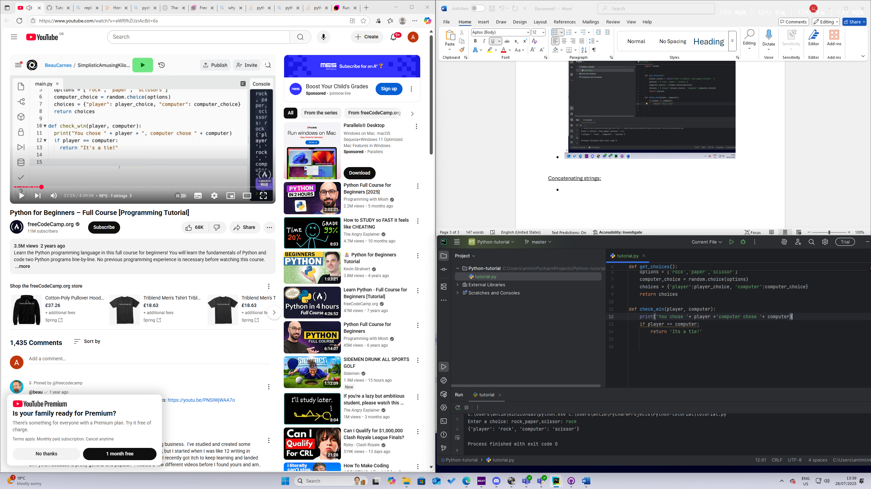
* done by ‘+’

f-strings

* ex:
* 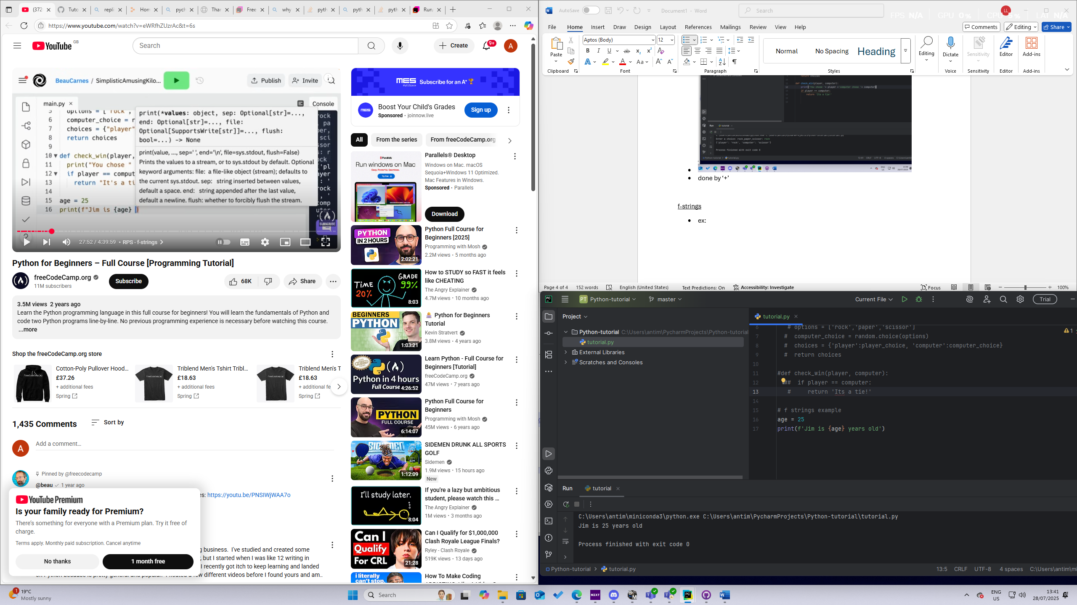
* Print(f’..{x}..’) – where x is a variable

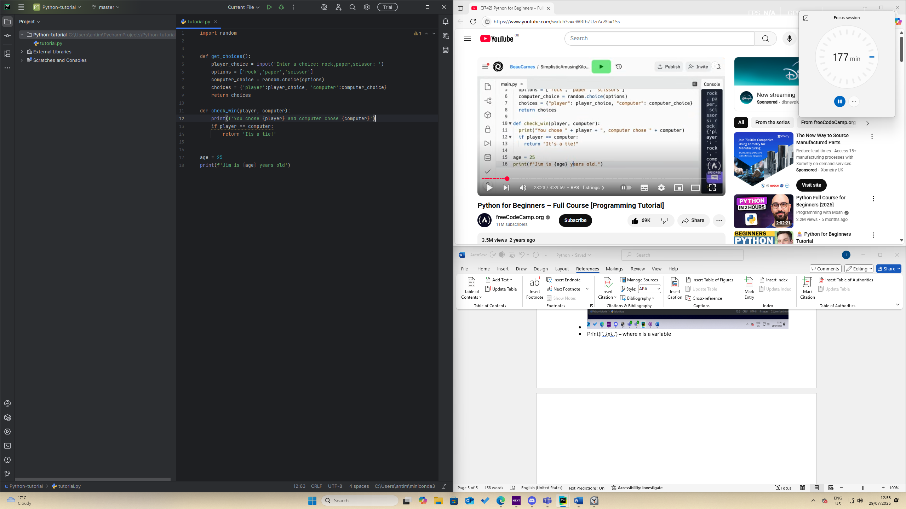

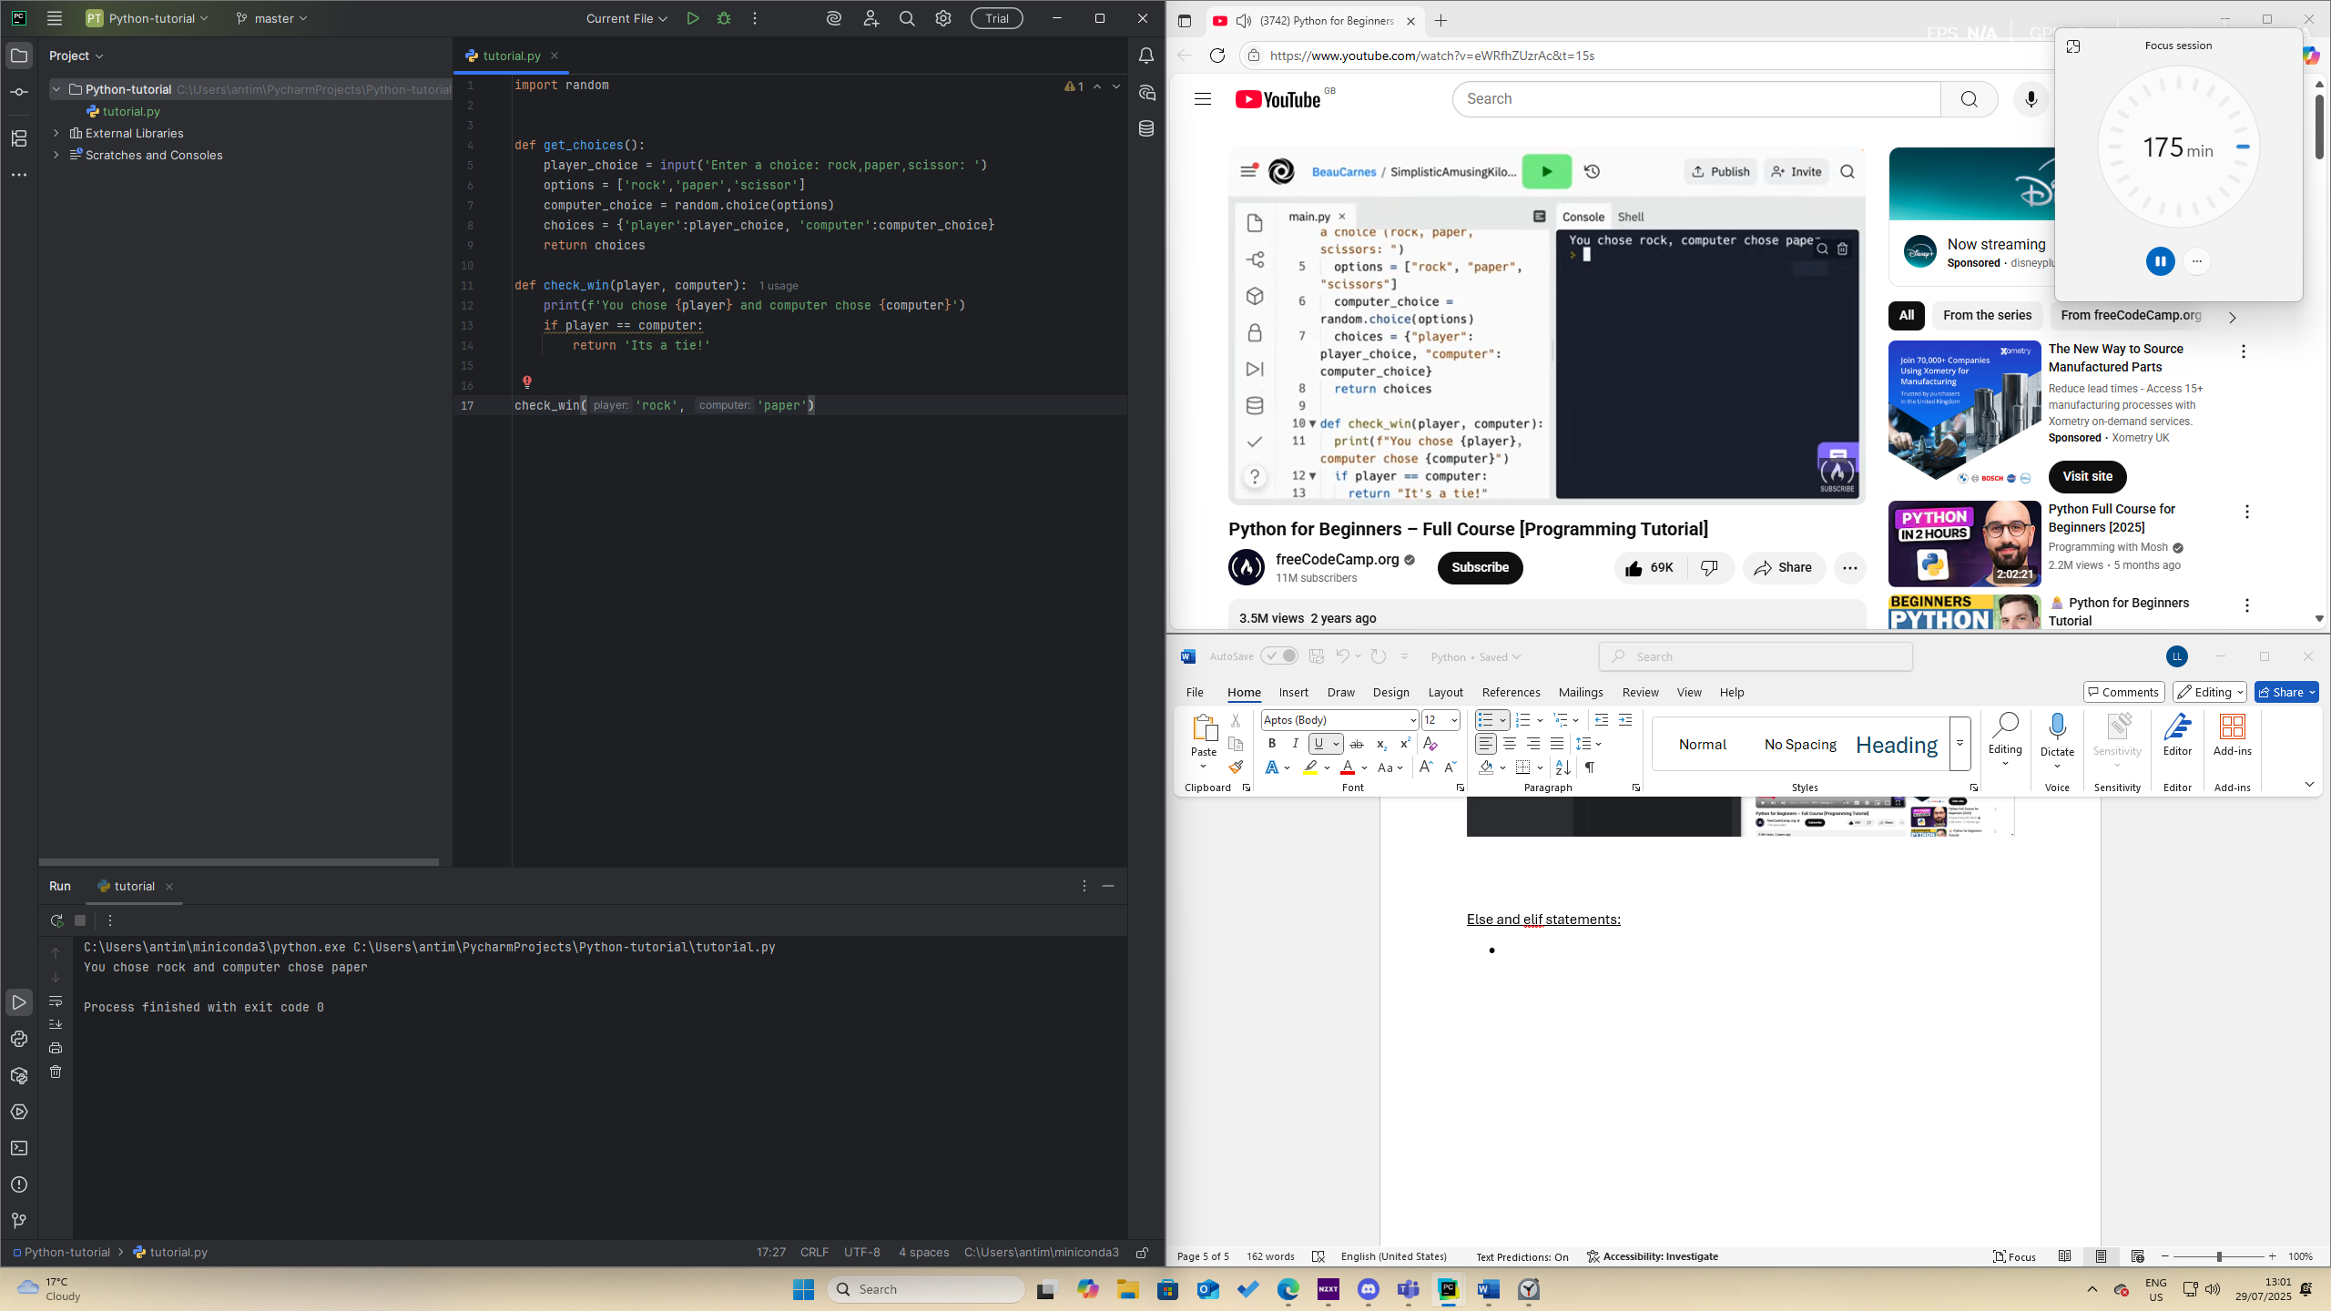

Else and elif statements:

* Elif statements go in between the first if statement and the last else statement
* 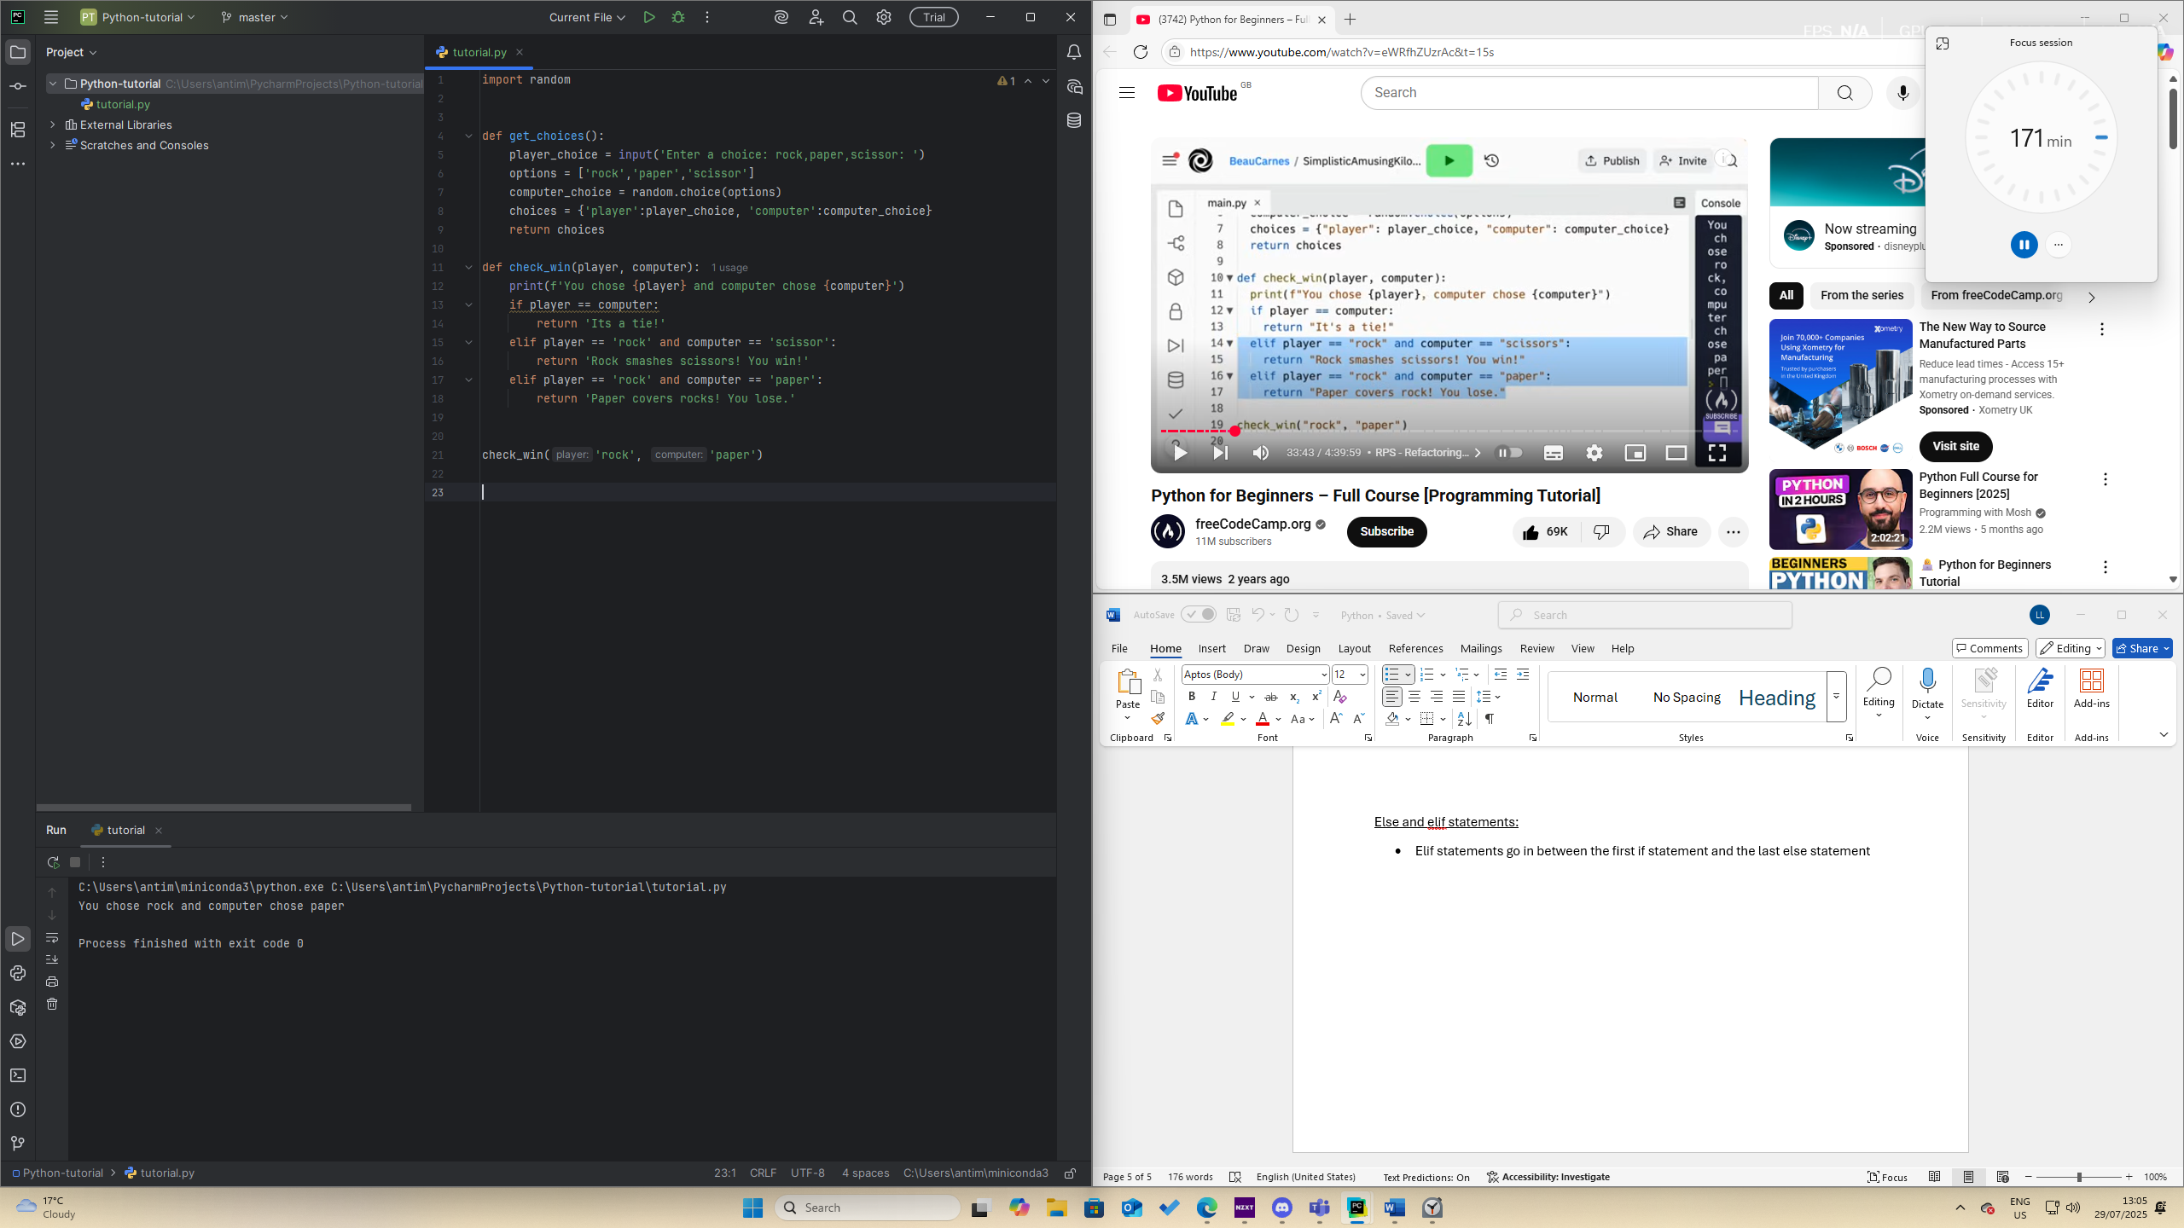

Refactoring and nested ifs

* The process of restructuring the code while keeping the original functionality
* Common to refactor code to make it simpler
* 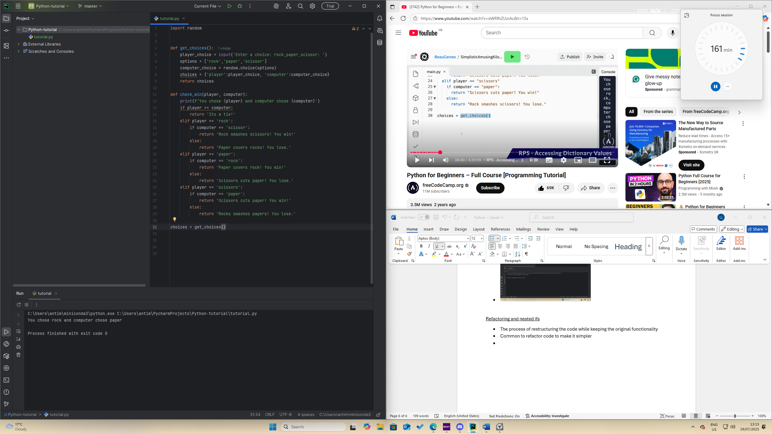

Accessing dictionary values

* 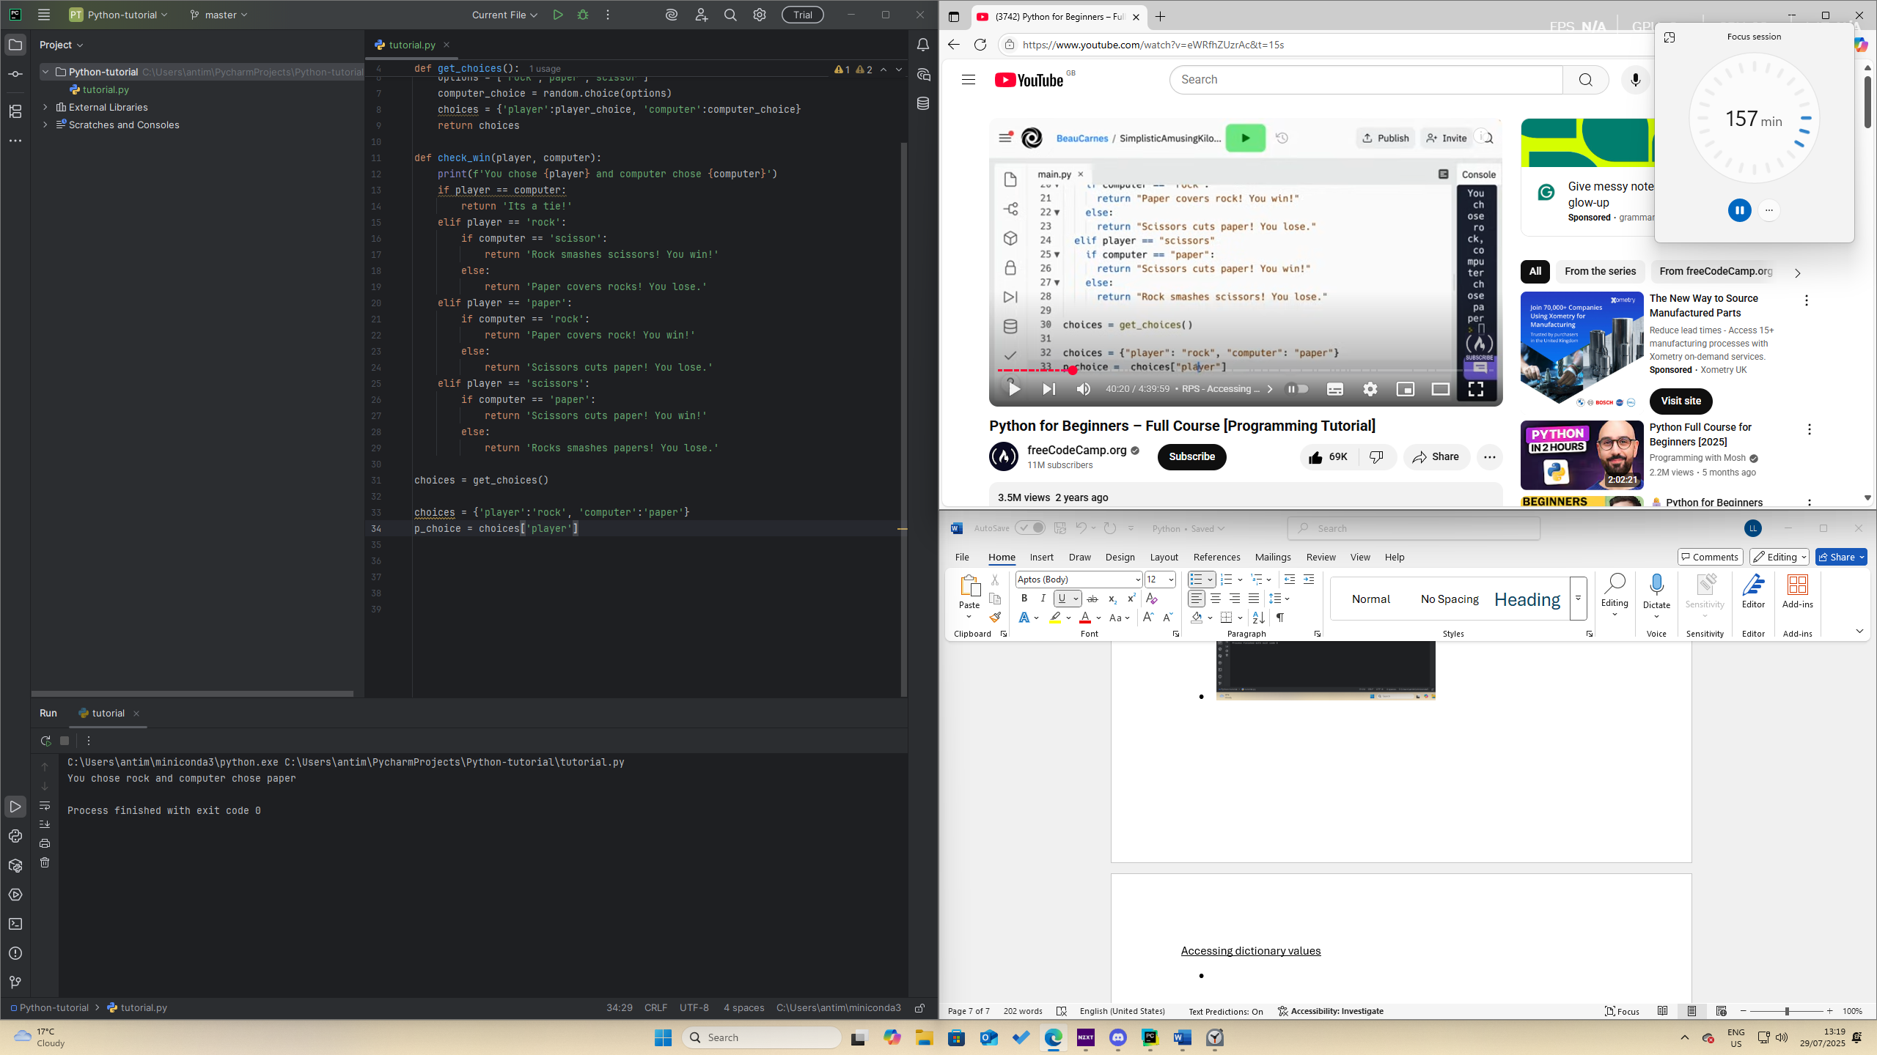
* Example: choices
* To access a value from a dictionary, you say x (variable name) = dictionary_name[‘key’]
* 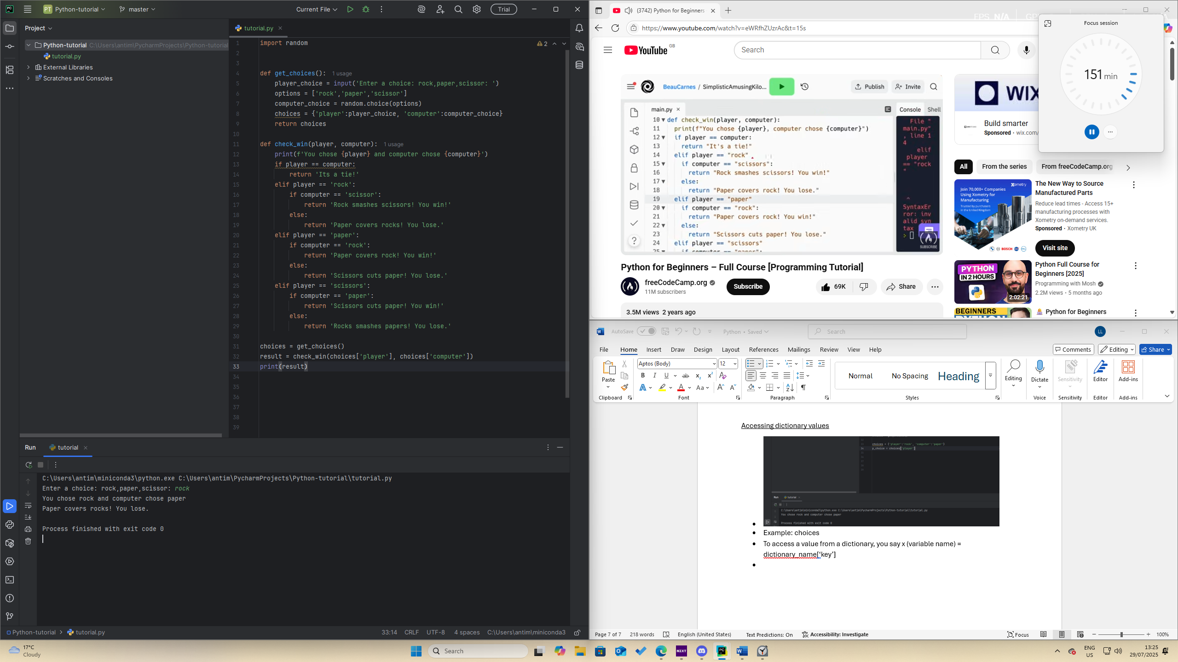

Variables

* use an = sign
* Cannot start with a number, cannot use characters and key words(while, if, etc)

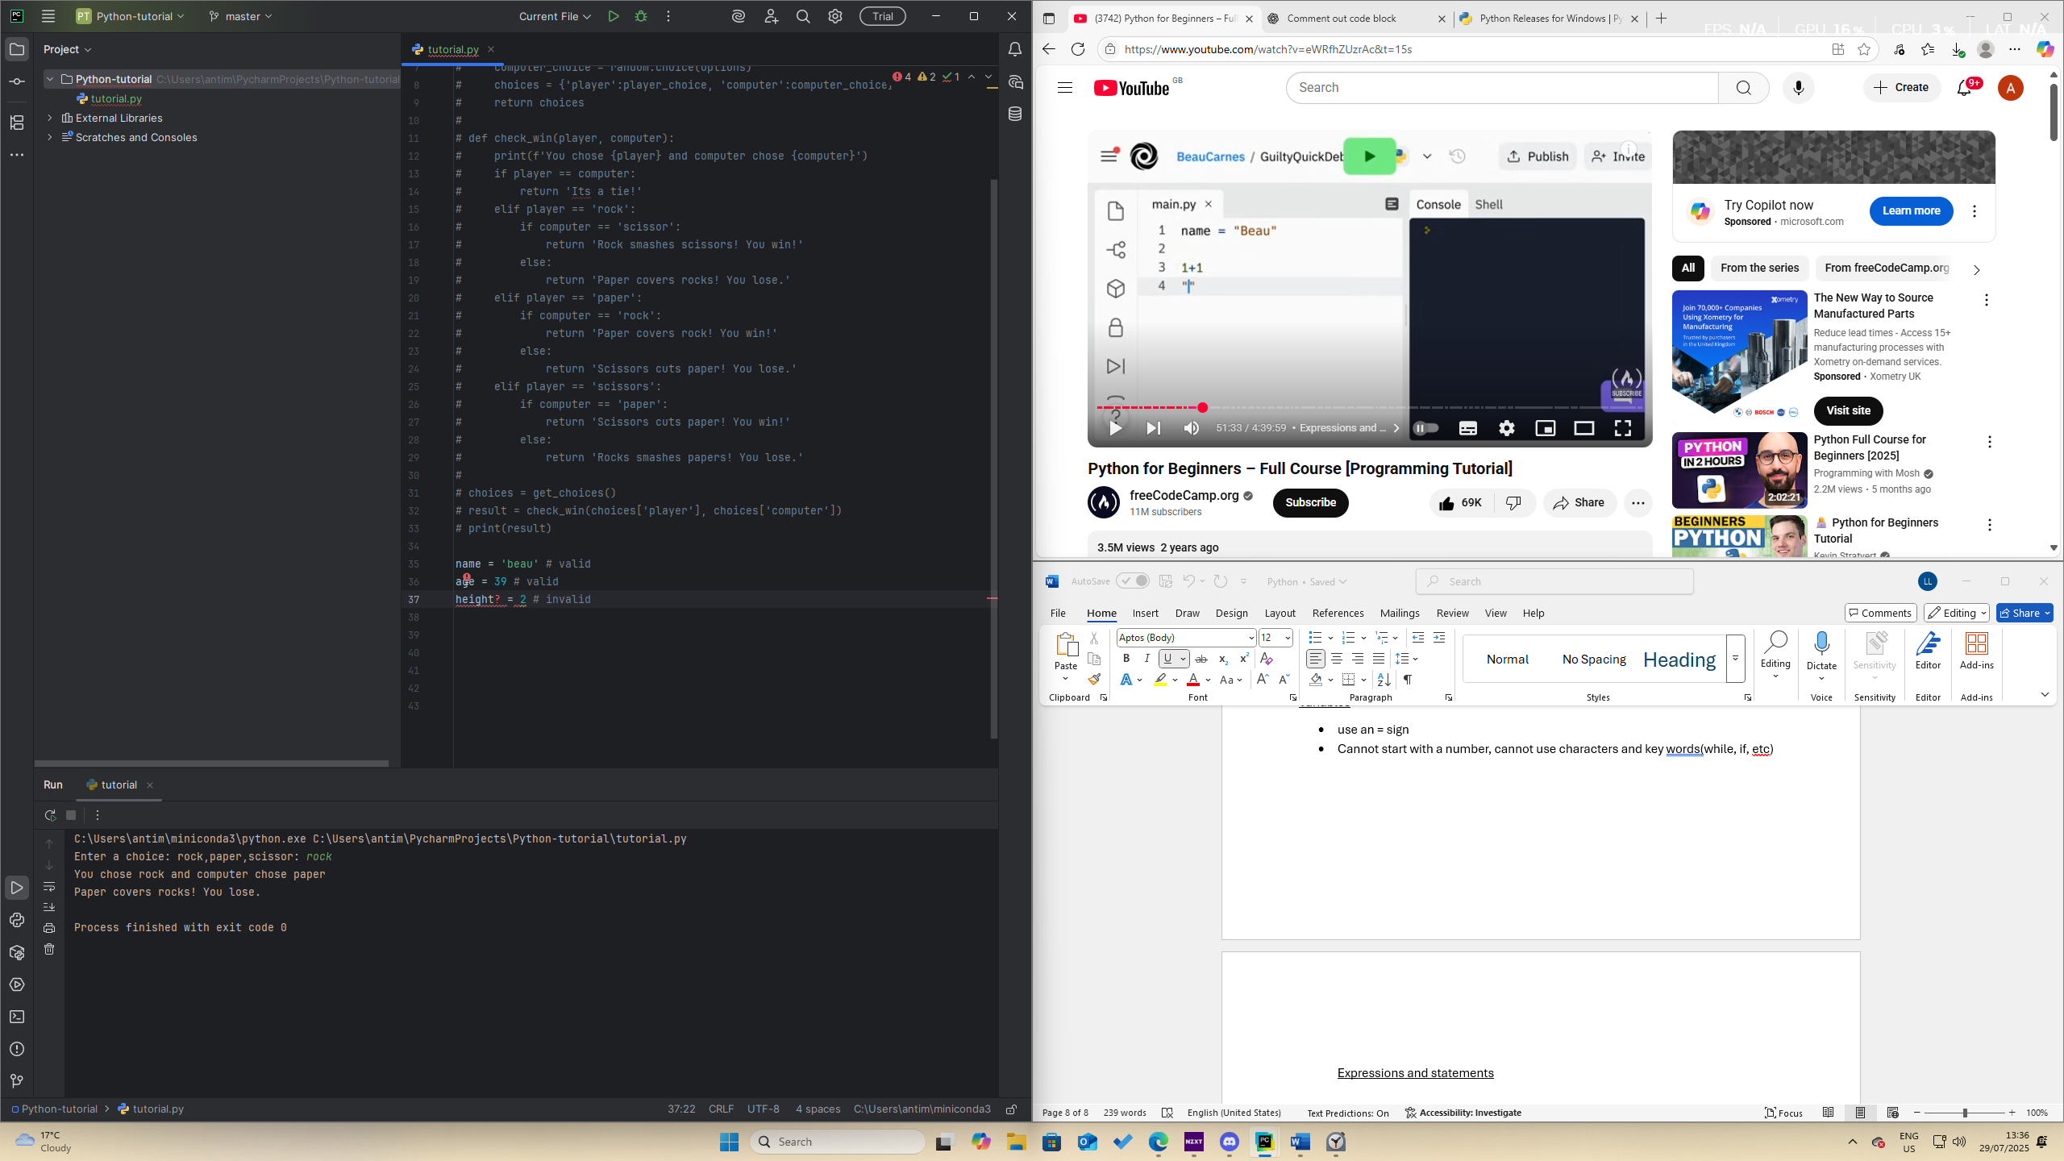

Expressions and statements

* Expression – any piece of code that returns a value
* Statement – operation on a value
* Can use a semi colon on a line to separate expressions and statements
* 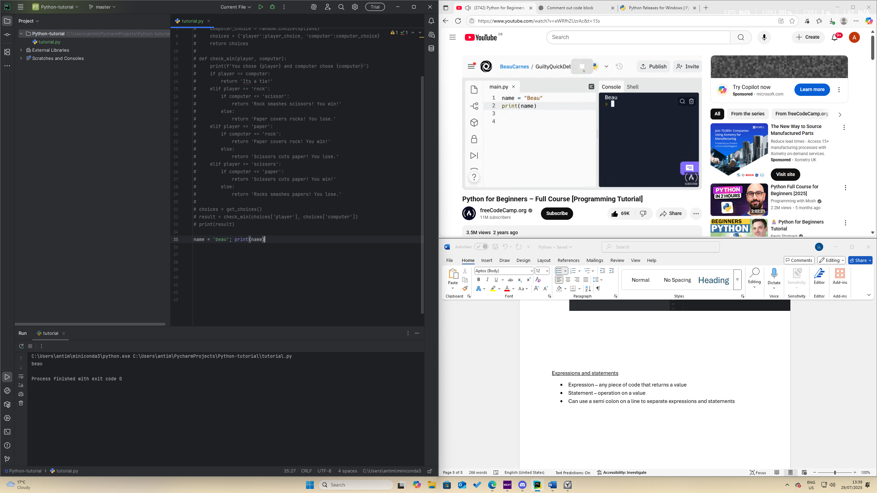

Comments

* Anything after # is ignored, useful for comments

Data types:

* Integers, strings, characters, Boolean, float
* 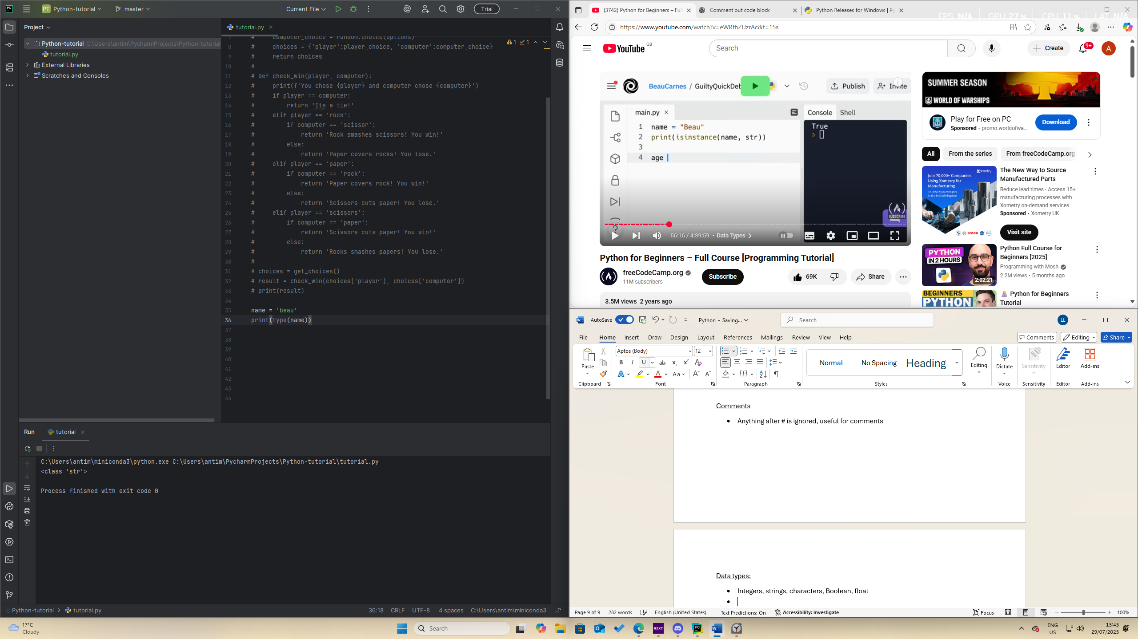
* Type is used to check what type of data type a variable is
* 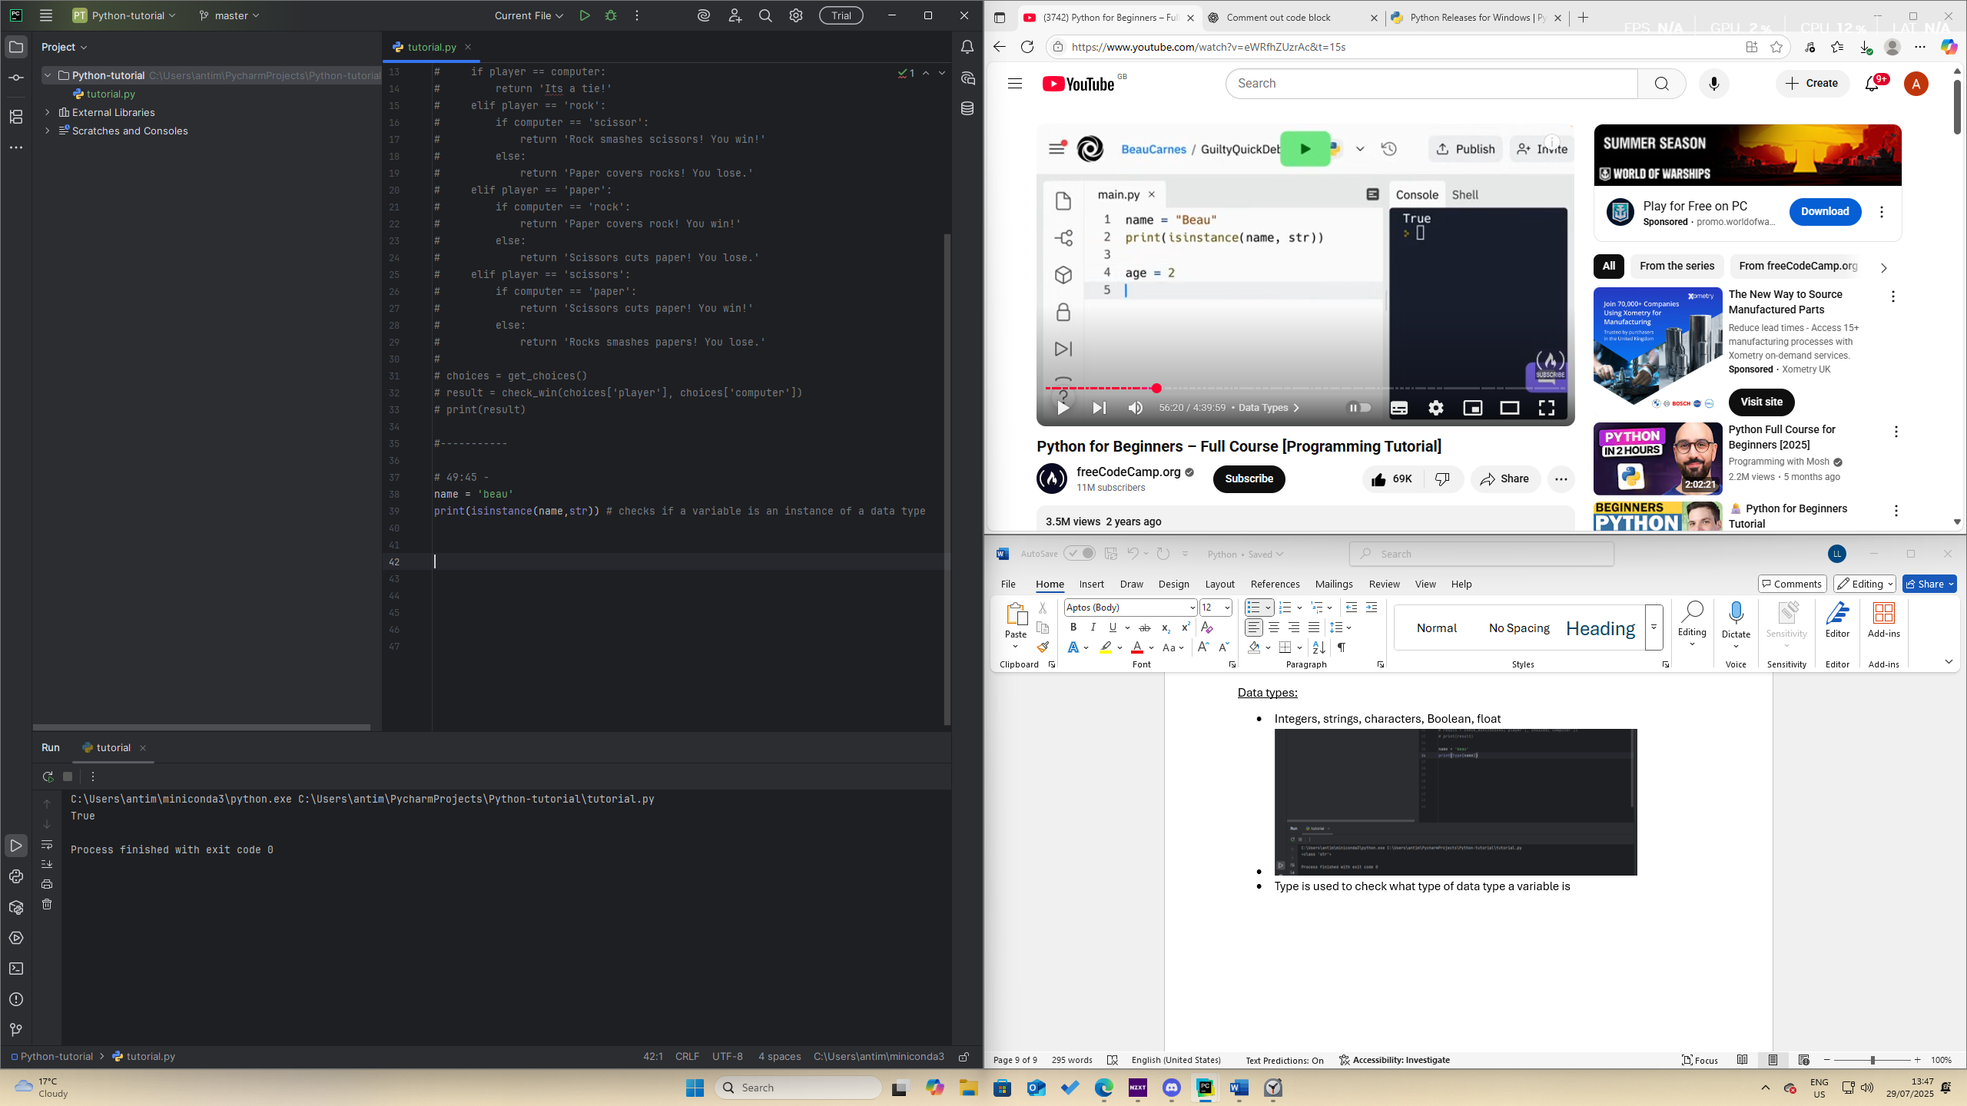
* Casting – changing one data type to another
* 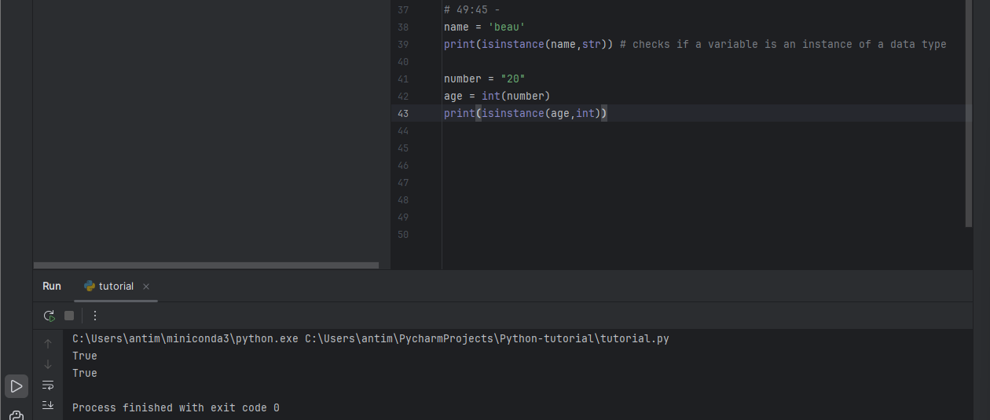
* complex for complex numbers
* bool for Booleans
* list for lists
* tuple for tuples
* range for ranges
* dict for dictionaries
* sets for sets

Operators

Arithmetic

* + adds numbers also used for concatenation
* - subtracts numbers
* * multiplies numbers
* / divides numbers, ex 3 / 2 returns 1, how many times 2 goes into 3
* %, returns the reminder of the division between number, ex 3 % 2 returns 1
* **, power function, 2 **3 returns 8
* //, floor division, rounds down to the nearest whole number, 5//2 returns 2
* 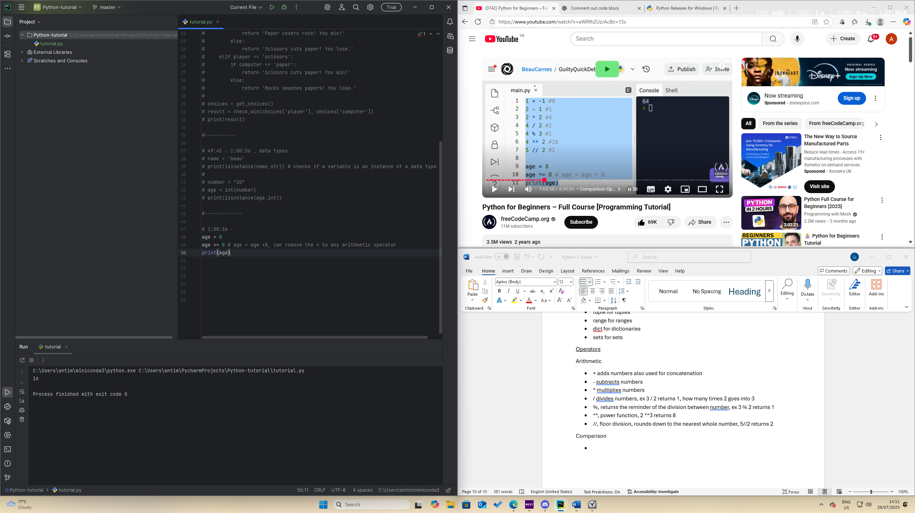

Comparison

* Return true or false
* > greater than
* >= greater than or equal to
* <= less than or equal to
* == equal to
* != not equal to

Boolean operators

* or, returns the value of an operand that doesn’t return a false value, if x is false y else x
* and, evaluates the 2nd argument if the first argument is false
* not,

bitwise operators

* & performs binary AND
* | performs binary OR
* ^ peforms a binary XOR operation
* ~ performs a binary NOT operation
* << shift left operation
* >> shift right operation

Is and in operations

* is – identity operator, used to compare 2 objects and returns true if both are the same objects
* in – membership operator, tells whether a value is contained in a list

Ternary operator

* 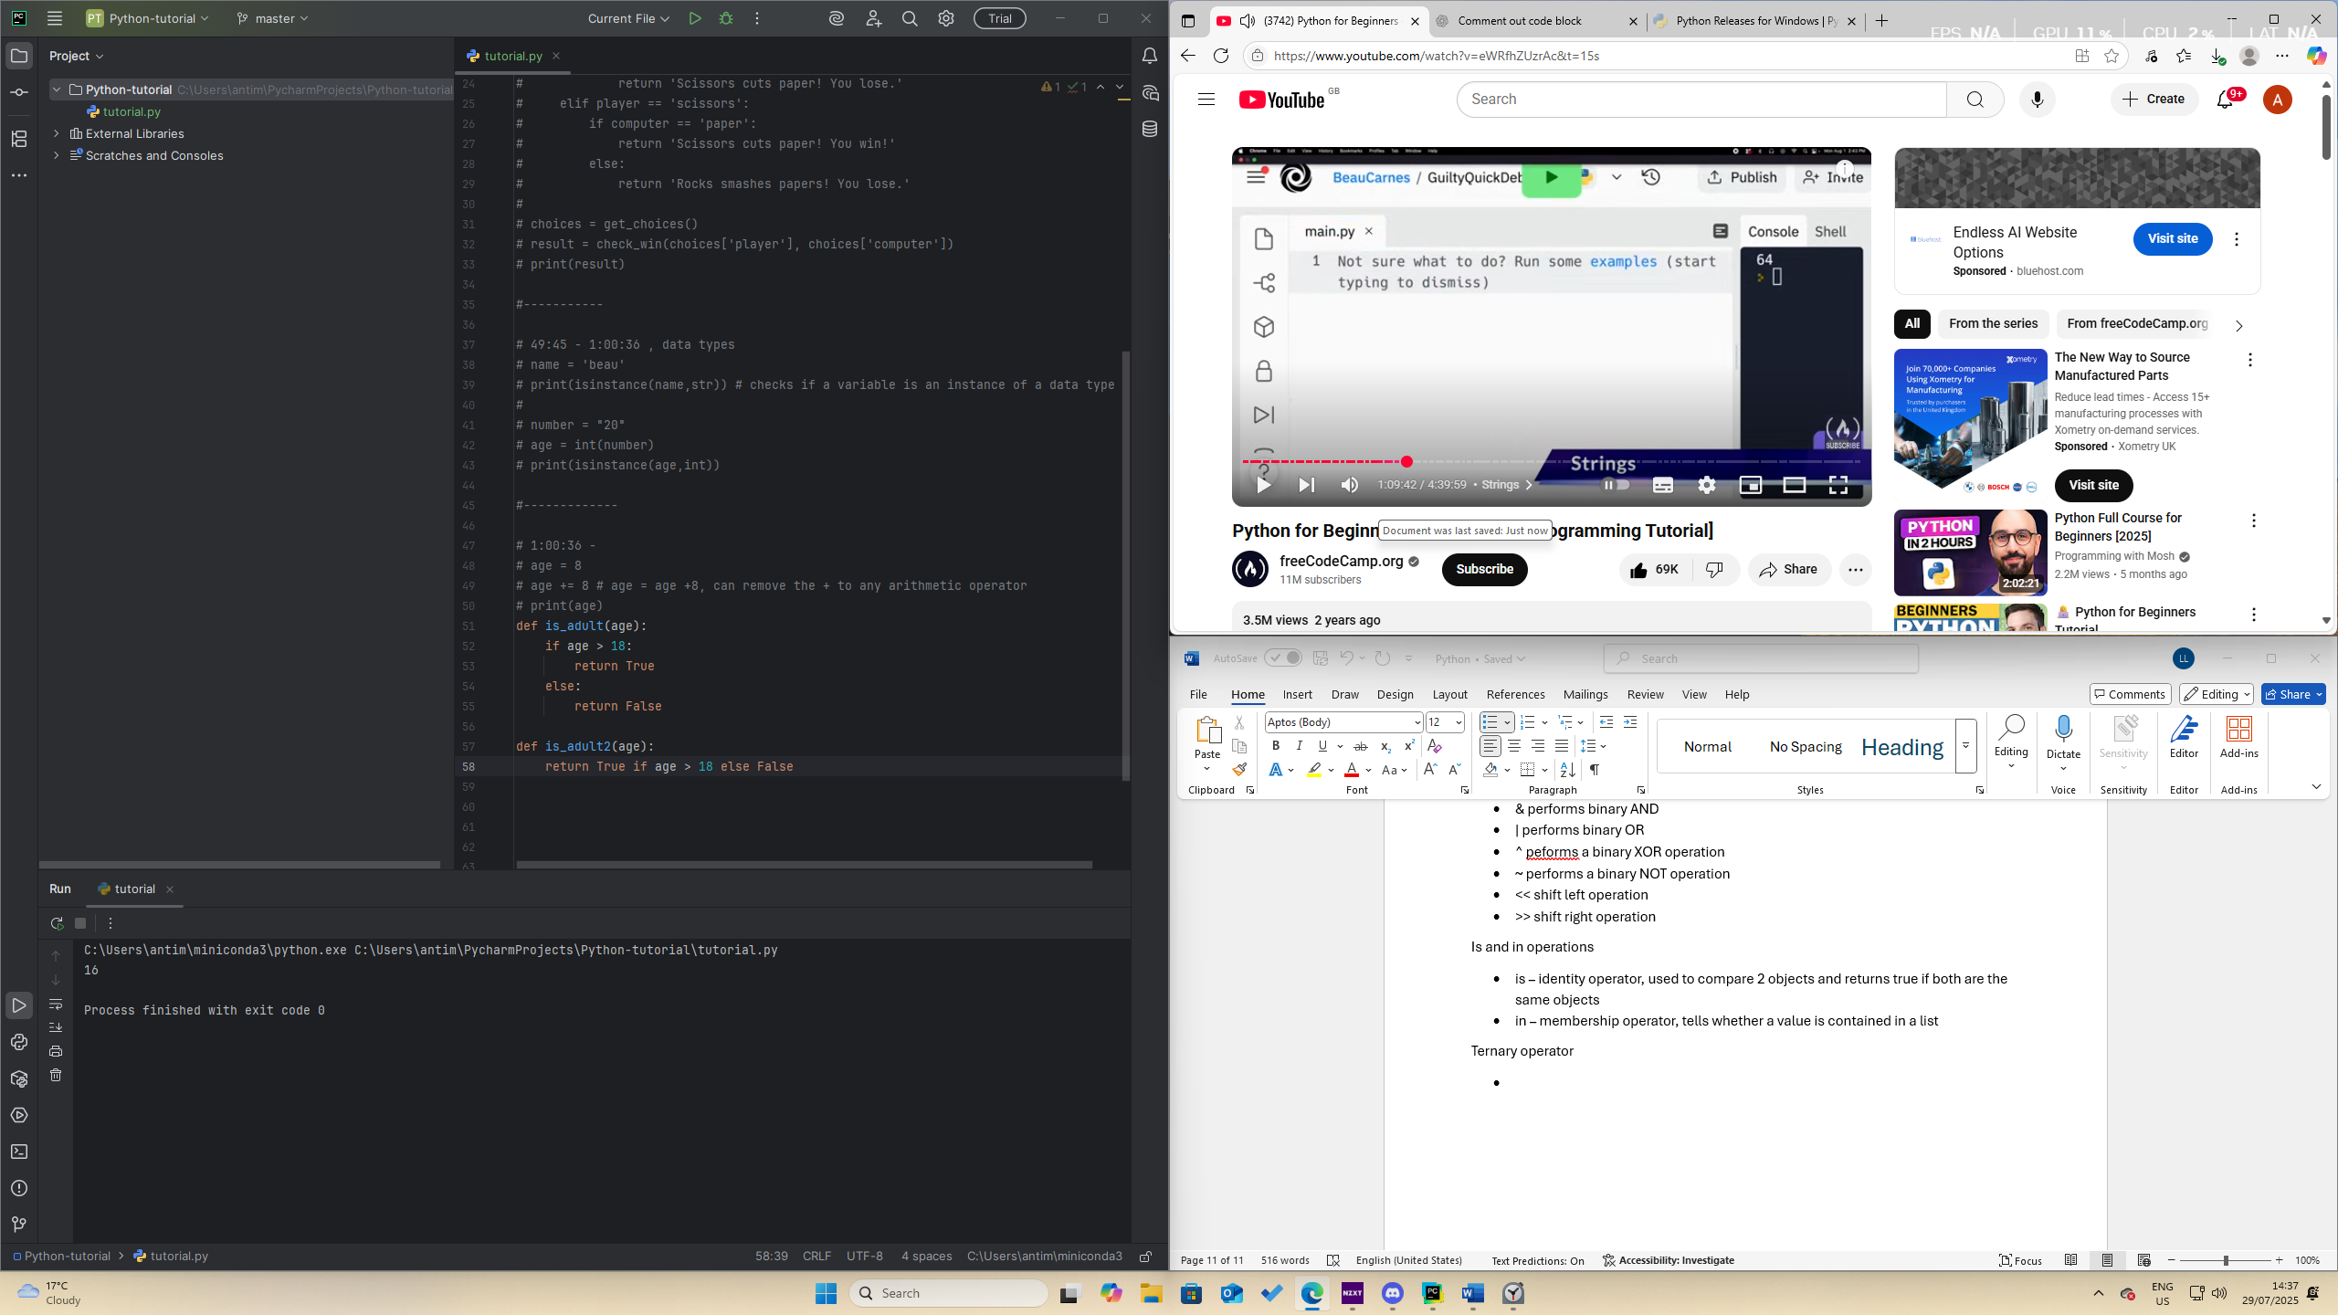
* In summary, its just writing an if and else statement on 1 line

Strings

* + is used to concatenate strings
* 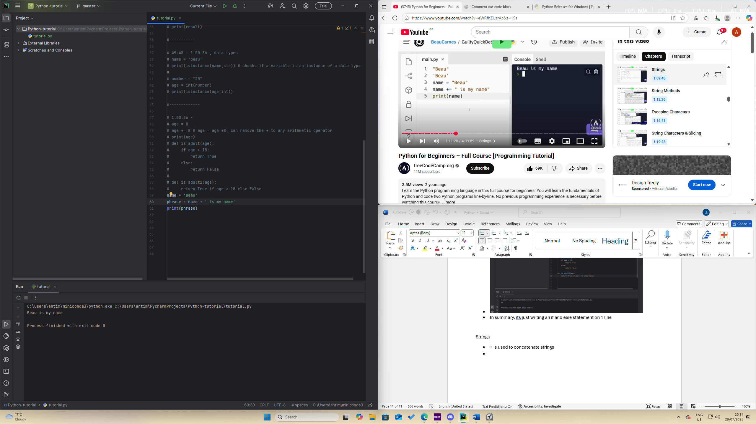
* 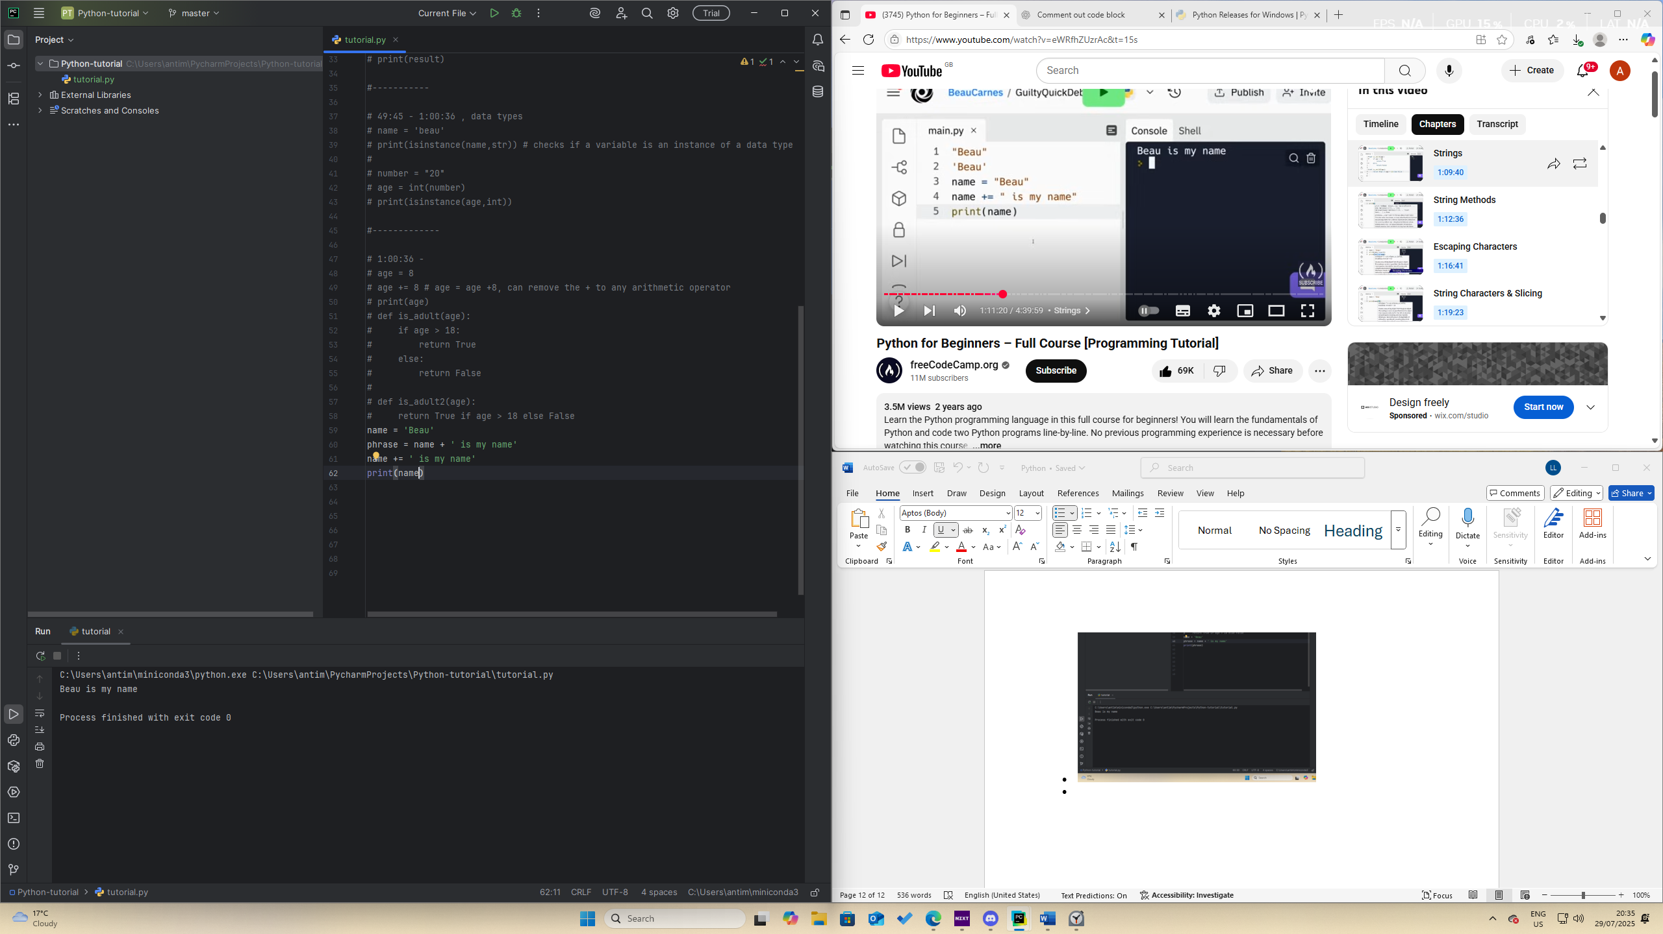
* Multi line strings are defined by “””” “”””
* .upper ()– makes all characters uppercase
* .lower ()– makes all characters lower case
* .title() – makes the first letter of every string capital
* .islower() – checks if all the letters of the string are lower case
* .isupper() – checks if all the letters of the string are upper case
* .isalpha() – checks if a string contains only characters and is not empty
* .isalnum() – checks if a string contains characters or digits and is not empty
* .isdecimal() – checks if a string contains digits and is not empty
* .startsswith() – checks if the string starts with a specific substring
* .endswith() – checks if the string ends with a specific substring
* .replace() – replaces a part of the string
* .split() – to split string on a specific character separator
* .strip() – to trim the whitespace from a string
* .join() – to append new letters to a string
* .find() – to find the position of a substring
* len() – finds the length of the string
* All of the functions above don’t change the original string